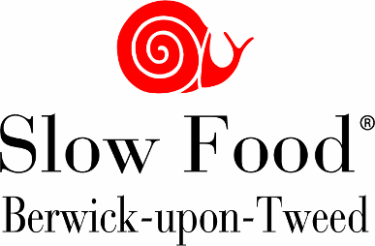 | Berwick Food & Beer Festival 2022  3rd & 4th September

Street Food Pitch Application

Company Name

Contact Name

Address
(including postcode)

Email address

Telephone no.

Mobile on
Festival day

Produce for sale. | Food producers must include a Food Hygiene Certificate with this application.
Food Hygiene cert | YES Enclose certificate with application
Electricity  Supply | Please note that there is no electricity available to Street Food vendors. All must provide their own generator.
PAT Cert for all electrical items | YES | Copy must be sent to the organisers with application please
Public liability  Insurance | YES | Copy must be sent to the organisers with application please

Choose one of the following options;
1 - I will be paying the full price of £ 250

2 - My business demonstrates a Slow Food ethos and I therefore qualify for the £10 and I will make the payment of £240
(extra £10 discount offered to Slow Food members also)

**you must provide a statement to support the claim that your business uses slow, traditional methods & please link to your website**

Cheques payable to Berwick Slow Food Festival,
Send to Ken Hardy, Treasurer, 15 Westfield Road Berwick upon Tweed TD15 1PT

OR pay by BACS to: Sort Code 12-12-57. Account 06003868

I confirm I have read and undertake to abide by the terms and conditions of the Berwick Food & Beer Festival. This includes the additional clause regarding the use of eco friendly disposables. This year's festival will be plastic & polystyrene free. [ ]

Signed.............................................................................

Optional Information for Festival Website

Details about your business

Please attach a link to your business Logo

